CNN-CPP Framework
Marko Kostić
Facultacy of Technical Sciences
kostmarko99@gmail.com
November 19, 2024

Abstract
Convolutional Neural Networks (CNNs) have transformed applications involving image classification and computer vision tasks. While widely adopted deep learning libraries like TensorFlow and PyTorch offer user-friendly environments for building neural networks, their high-level abstractions often limit control over low-level operations. This paper presents CNN-CPP, a CNN framework implemented entirely in C++, providing an adaptable and precise alternative for researchers and developers. CNN-CPP supports modular design for standard layers and optimizers, including batch normalization and advanced gradient-based optimizers, while also introducing the custom Epoch Loss Recovery Adaptive Learning Early Stopping (ELRALES) mechanism to enhance training efficiency. Utilizing double-precision arithmetic, CNN-CPP achieves increased accuracy on challenging datasets, such as CIFAR-10, compared to 32-bit and mixed-precision models. Experimental results demonstrate the framework’s ability to outperform TensorFlow in accuracy and precision for specific configurations on same models. Although CNN-CPP runs at slower speeds, it remains valuable for applications that require fine-grained control over neural network training.

INTRODUCTION
Since their introduction in the 1980s, Convolutional Neural Networks (CNNs) have become a cornerstone of modern computer vision. Inspired by biological visual processing, CNNs utilize a series of learnable filters and hierarchical feature extraction to process image data [7]. This architecture allows CNNs to excel at image classification, object detection, and semantic segmentation, making them integral to fields ranging from autonomous driving to medical imaging [8], [9]. The success of CNNs grew with advancements in hardware and large-scale datasets, and their efficiency has been further enhanced by software frameworks like TensorFlow and PyTorch [5]. Despite their effectiveness, popular high-level frameworks can constrain low-level control, limiting options for developers who need specific precision or optimizations. Many applications, particularly in research or constrained environments, benefit from a framework that allows for fine-tuned management over computation details and optimizations. Addressing this need, CNN-CPP provides a C++ framework that supports flexible, high-precision CNN implementations without relying on high-level abstractions.

CNN-CPP Overview
CNN-CPP is a comprehensive framework built from scratch in C++ for designing and training CNNs. Emphasizing modularity and flexibility, it supports custom model creation with a focus on image processing and classification. By leveraging C++ features and libraries, including Eigen [3] for tensor operations and OpenCV [4] for image handling, CNN-CPP combines powerful computation with accessible functionality, catering to developers seeking an alternative to mainstream frameworks.

Inspiration
Inspired by TensorFlow’s versatility and power, CNN-CPP seeks to bring comparable capabilities to C++ users [5]. The framework enables the creation, training, and deployment of neural networks with robust customization and performance, providing control over each layer and operation. By mirroring key components found in widely used frameworks, CNN-CPP offers an accessible but adaptable platform for deep learning in C++.

Key Features
CNN-CPP supports core CNN components, including convolutional layers, activation layers, pooling layers, and fully connected layers, as well as essential functionalities like batch normalization, learning decay and gradient clipping. The framework introduces an innovative mechanism, Epoch Loss Recovery Adaptive Learning Early Stopping (ELRALES), which dynamically adjusts the learning rate in response to fluctuations in model performance across epochs, with an aditional ability to restore the model to previous best epoch. This adaptation improves stability and training efficiency, especially on complex datasets, while allowing developers to optimize the training process effectively.

Precision and Performance
One distinguishing feature of CNN-CPP is its reliance on double-precision arithmetic, which enables greater accuracy and stability in training, particularly with challenging datasets like CIFAR-10 [6]. Although double-precision calculations slow down processing compared to frameworks like TensorFlow [5], they allow CNN-CPP to achieve competitive or superior accuracy under certain configurations. This focus on high precision makes CNN-CPP an ideal choice for applications requiring detailed control over the neural network training pipeline and maximum computational accuracy [8].

Theorical Concepts and Approaches
Convolutional Neural Networks (CNNs) are a specialized form of neural networks widely used in image processing tasks. The network architecture is inspired by the visual processing mechanism in animal brains, leveraging a hierarchy of convolutional, pooling, and fully connected layers to extract and learn spatial and hierarchical features from images [7]. These architectures have been instrumental in advancing fields such as object detection, image classification, and medical imaging, with contributions from foundational works and modern frameworks such as TensorFlow enhancing their efficiency and accessibility [5], [8], [9].

Convolution Layer
The convolutional layer is the core building block of a CNN, responsible for detecting local patterns in input data. It applies a series of learnable filters or kernels that slide across the input image, convolving and generating feature maps [7], [8]. Each kernel detects specific features, such as edges, textures, or shapes, which become increasingly abstract as more layers are added. There are various types of convolutions, such as depth-wise, spatial, flattened, and inverse convolutions. In this paper, we focus on the standard convolution, where feature maps are formed per filter, summing their results across the input's depth to capture complex spatial patterns.

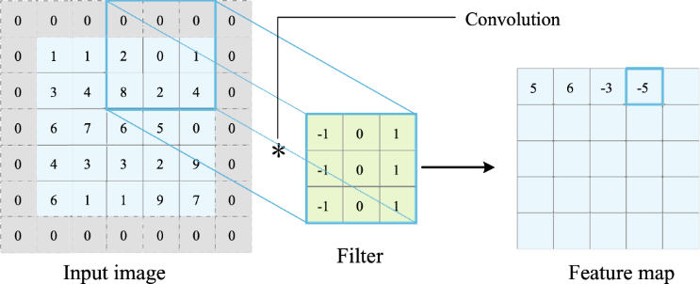
Figure 1 Convolution Operation
The framework uses a thread pool to parallelize forward and backward convolution operations on each image, optimizing the processing of batches during training. This approach significantly accelerates convolution layers by distributing workloads across available CPU threads. The thread pool automatically initializes based on the number of available hardware CPU threads, and maximizing efficiency is best achieved by configuring batch sizes as multiples of the CPU's thread count. This parallelization strategy ensures efficient utilization of resources and reduces training time, particularly in convolutional layers [1], [2].

Activation Functions (Layers)
After each convolution operation, an activation function, typically ReLU, is applied to introduce non-linearity into the network. This non-linearity allows CNNs to capture complex patterns in the data and enhances model expressiveness by implementing a zero-threshold, which helps mitigate issues like vanishing gradients [10]. The framework supports adding activation layers after any layer in the network, offering flexibility in network design. In contrast, frameworks like TensorFlow also allow activations to be integrated directly within specific layer definitions, providing additional customization options [5]. Supported activations include ReLU, Leaky ReLU, ELU, Tanh, Sigmoid, and Softmax.

Pooling Layers
Pooling layers reduce the spatial dimensions of the feature maps, preserving only the most significant information while lowering computational requirements. Max pooling is the most commonly used technique, which downsamples the input by retaining the maximum value within a sliding window, effectively capturing the most prominent features in each region and introducing a degree of translation invariance. In contrast, average pooling computes the average of all values within the sliding window, resulting in a smoother representation by capturing the overall intensity of features rather than focusing on the strongest response. Average pooling is typically less effective than max pooling for capturing sharp details but can be useful in applications where general patterns are more relevant than specific features. Max Pooling and Average Pooling layers are supported by the framework, alowing them efficiently handle both the forward and backward passes.

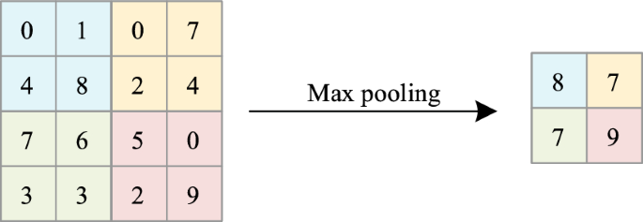
Figure 2 Max Pooling
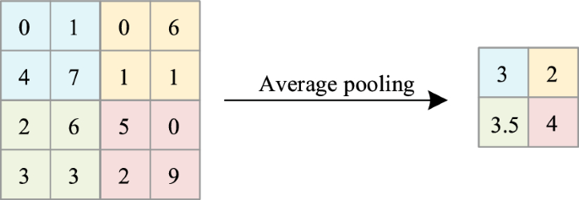
Figure 3 Average Pooling

Flatten Layer
The flatten layer serves as a bridge between the convolutional or pooling layers and the fully connected layers in a CNN. After feature extraction in the convolutional and pooling layers, the flatten layer reshapes the multidimensional feature maps into a one-dimensional vector, making it possible for the fully connected layer to process the data as a continuous input and make predictions based on all learned features. This transformation preserves all extracted features and prepares them for final classification or regression tasks.

In the CNN-CPP framework, the flatten layer explicitly reshapes the 4D tensor into a specific 4D tensor format (batch_size, 1, 1, flattened_size), maintaining compatibility with downstream layers. In contrast, TensorFlow handles flattening with greater abstraction, typically reshaping directly into a 2D tensor (batch_size, flattened_size) and often embedding this reshaping within other layer definitions [1][5]. CNN-CPP’s explicit 4D reshaping [3] provides controlled transformations that seamlessly align with the manual setup of subsequent fully connected layers. This approach ensures that all layers can inherit from the abstract Layer class with consistent method signatures for both forward and backward passes, while avoiding unnecessary memory usage by using higher-dimension tensors with single vector elements per dimension as needed.

Fully Connected (Dense) Layers
The fully connected layer, or dense layer, is typically found near the end of the network. It connects each neuron to every neuron in the previous layer, or if first to Flatten Layer enabling the network to make final classification decisions based on the high-level features extracted from the preceding layers. This layer outputs the class probabilities in a classification task, often with a softmax function applied to convert the values to probabilities [5].
In CNN-CPP, the fully connected layer explicitly reshapes the 4D input tensor (batch_size, 1, 1, input_size) to a 2D tensor (batch_size, input_size) for matrix multiplication during the forward pass, and then back to a 4D output tensor (batch_size, 1, 1, output_size). Similarly, in the backward pass, gradients are reshaped explicitly to match these specific 4D tensor dimensions, providing clear control over each transformation. In contrast, TensorFlow simplifies this by handling dense layers directly with 2D tensors (batch_size, input_size) throughout the forward and backward passes [3][5].

Optimizers
Optimizers are essential for adjusting neural network weights in a way that minimizes the loss function. Stochastic Gradient Descent (SGD) updates weights by moving them in the direction of the negative gradient of the loss function, though it can sometimes converge slowly or get trapped in local minima. An enhanced version, SGD with Momentum, accelerates convergence by incorporating a fraction of the previous update into the current one, which helps maintain consistent progress through areas of low gradient values. RMSprop (Root Mean Square Propagation) further adapts the learning rate by dividing the gradient by a moving average of its recent magnitudes, thereby reducing oscillations and stabilizing updates—especially useful in complex or noisy data scenarios. Finally, Adam (Adaptive Moment Estimation) combines the benefits of both momentum and RMSprop, using moving averages of both the gradients and their squared values to dynamically adjust the learning rate for each parameter. This often leads to faster convergence and requires less tuning, making Adam a popular choice for many deep learning applications [5][9][10]. In CNN-CPP, optimizer hyperparameters for each layer are initialized during the first backward pass except SGD. This setup automatically adjusts dimensions to match each layer’s specific parameter shapes, like kernels, weights and biases, without manual pre-configuration. Each layer manages its own hyperparameter state, with unique values allocated per layer.

Loss Function
The loss function quantifies the difference between the network's predictions and the actual labels, providing a feedback signal for learning. Common loss functions for classification tasks include categorical cross-entropy and binary cross-entropy, which measure the discrepancy between predicted and true class probabilities. The choice of loss function impacts how the model learns and optimizes during training [7]. The framework currently supports Binary Cross-Entropy and Categorical Cross-Entropy for classification tasks, as well as Mean Squared Error.

Batch Normalization
Batch normalization is a technique used in neural networks to stabilize and accelerate training by normalizing the inputs to each layer. It adjusts and scales the inputs to have a mean of zero and a variance of one, typically based on batch statistics [7]. This normalization helps reduce internal covariate shift, allowing the network to learn more efficiently and enabling the use of higher learning rates. Additionally, batch normalization includes learnable parameters, gamma (scale) and beta (shift), which allow the model to maintain flexibility by scaling and shifting the normalized output, adapting to different distributions if needed [8].
In the CNN-CPP implementation, batch normalization parameters such as gamma (scale), beta (shift), moving mean, and moving variance are initialized during the first forward pass. Gamma and beta are initially set to 1 and 0, respectively, allowing the network to gradually learn their values during training. The implementation also distinguishes between training and inference modes. In training mode, batch statistics are calculated, and moving averages are updated, whereas in inference mode, these moving averages are used directly, ensuring consistent normalization across batches. This setup provides flexibility and mirrors TensorFlow's approach [5].

Gradient Clipping
Gradient clipping is a technique used to prevent the exploding gradient problem in deep networks, especially when training with high learning rates or on complex data [9]. It limits the magnitude of gradients by clipping them to a maximum and minimum threshold, which keeps weight updates within a stable range and helps maintain training stability [10]. In CNN-CPP, gradient clipping is implemented to limit the values of gradients tensor within a specified threshold range. This approavh takes in a gradient tensor and applies a clipping threshold, restricting each gradient value to be within minus and plus threshold value.

Learning Rate Decay
Learning rate decay reduces the learning rate as training progresses, allowing the network to make finer adjustments in the later stages of training. Popular decay strategies include step decay, exponential decay, and adaptive decay methods. Learning rate decay helps prevent the model from overshooting the optimal solution and can improve final accuracy [10]. In CNN-CPP, several learning rate decay strategies are implemented to support controlled adjustments to the learning rate throughout training. Supported decay types include Exponential Decay, Step Decay, Polynomial Decay, Inverse Time Decay, and Cosine Decay. Each decay type has specific parameters that define its behavior, which are configurable when initializing the decay method.

Implementation Details and Capabilities
The NeuralNetwork class in the CNN-CPP framework serves as a comprehensive system for building, configuring, training, and evaluating neural networks. It enables extensive customization options, including network architecture management, training configurations, logging, and adaptive learning strategies. Here’s an in-depth look at its key functionalities:

Layer Management and Customization
The NeuralNetwork class in the CNN-CPP framework enables the addition and configuration of multiple layer types for flexible model construction. Convolutional layers are highly customizable, with options to specify filter count, kernel size, stride, padding, kernel initialization, and bias initialization, allowing adjustments to network depth and spatial dimensionality at each layer. Pooling layers, both max and average, allow the user to control window size and stride, enabling effective dimension reduction. Fully connected layers support customization of neuron number as well as initialization methods for weights and biases. Batch normalization layers can be added with configurable epsilon and momentum values to manage internal layer normalization.
The compile method configures these layers by ensuring compatible connections across the network and assigning optimizers to trainable layers based on the specified optimizer type (e.g., SGD, Adam, RMSprop) with default or custom parameter values. During compilation, the method calculates the height, width, depth, number of neurons and input dimensions for each layer based on its predecessor, ensuring seamless integration. Batch normalization layers are assigned a target type, depending on the preceding layer, to maintain contextual integrity. Compile verifies that all essential components are in place, marking the network as fully initialized and ready for training.

Forward and Backward Propagation
During forward propagation, input data sequentially passes through each layer, with each layer’s output serving as the next layer’s input. Backward propagation computes gradients to optimize kernels, weights, biases, and other parameters such as gamma and beta in batch normalization layers. The framework applies these updates using the selected optimizer, with optional gradient clipping to maintain numerical stability and training reliability.

Training Management and Epoch Control
The train method oversees the full training process, from data loading to iterative forward and backward passes over multiple epochs. Users can adjust batch size, learning rate, and epoch count, with batch management handled by the BatchManager which also server as the input layer.

Evaluation and Prediction
Evaluation capabilities allow users to test the model’s performance on unseen data, with metrics such as accuracy and loss for validation. Batch normalization layers are set to inference mode during evaluation to ensure consistent predictions. For single predictions, the makeSinglePredictions function enables testing on small batches or individual images, displaying confidence scores alongside predictions to enhance interpretability.

ELRALES
The ELRALES (Epoch Loss Recovery Adaptive Learning Early Stopping) mechanism enhances neural network training by integrating adaptive learning rate adjustments, early stopping, and recovery. ELRALES monitors epoch loss, adaptively reducing the learning rate and restoring the model to its best state when losses deviate beyond a set tolerance. This mechanism initializes with parameters that control the learning rate reduction factor, limits on consecutive and total epoch failures, and a tolerance level that allows minor loss fluctuations. During training, if the current epoch achieves a new lowest loss, ELRALES updates the best loss and saves the model’s state, including parameters from all relevant layers. If the loss worsens within tolerance, ELRALES increments failure counts and reduces the learning rate by the specified factor, reverting to the best state if needed. Should failures exceed predefined limits, ELRALES halts training to prevent overfitting and avoid unnecessary computation, ensuring efficient, stable convergence.

Results
This section compares the training and validation performance between CNN-CPP (left column) and TensorFlow (right column) on the exact same models. Below you will find the training and validation accuracy and loss visualizations. For these tests, an Intel Core i7-10700K CPU was used (stock). The i7-10700K is an 8-core, 16-thread desktop processor with a base clock speed of 3.8 GHz and a turbo boost frequency of up to 5.1 GHz. This CPU offers strong single-threaded and multi-threaded performance, making it well-suited for tasks such as training neural networks. However, it does not support AVX-512 instructions, which could enhance performance in some deep learning workloads.

Cats Dogs Dataset
The model is trained and validated on a dataset containing images of cats and dogs:
- Training Data: 4,000 images of dogs and 4,000 images of cats.
- Validation Data: 1,000 images of dogs and 1,000 images of cats.
- Single Prediction Data: 1 dog image and 1 cat image for single prediction tasks.

Model Component | CNN-CPP Description | TensorFlow Description
Model Implementation | wmodels/cnn_cd_e30.hpp | tfmodels/cnn_cd_e30.py
Input Image Size | 32x32 pixels | 32x32 pixels
Convolutional Layer 1 | 32 filters, 3x3 kernel, ReLU activation | 32 filters, 3x3 kernel, ReLU activation
MaxPooling Layer 1 | 2x2 pool size | 2x2 pool size
Convolutional Layer 2 | 32 filters, 3x3 kernel, ReLU activation | 32 filters, 3x3 kernel, ReLU activation
MaxPooling Layer 2 | 2x2 pool size | 2x2 pool size
Flatten Layer | Converts 4D Tensor to 4D Tensor(2D) | Converts 2D matrices to 1D vector
Fully Connected Layer 1 | 128 units, ReLU activation | 128 units, ReLU activation
Fully Connected Layer 2 | 64 units, ReLU activation | 64 units, ReLU activation
Fully Connected Layer 3 | 32 units, ReLU activation | 32 units, ReLU activation
Output Layer | 1-unit Dense layer with Sigmoid | 1-unit Dense layer with Sigmoid
Loss Function | Binary Cross-Entropy | Binary Cross-Entropy
Optimizer | Adam with gradient clipping (clipvalue=1.0) | Adam with gradient clipping (clipvalue=1.0)
Learning Rate | 0.00005 | 0.00005
Batch Size | 32 | 32
Epochs | 30 | 30
Batch Mode | Uniform Distribution | Flow From Directory
Augmentation | Zoom (0.2), Shear (0.2), Horizontal Flip (50%) | Zoom (0.2), Shear (0.2), Horizontal Flip (50%)
Table 1 Cats Dogs Model
CNN-CPP Prediction | TensorFlow Prediction
Prediction for 'dog.jpg' is 'dog' with confidence 99.9252%. ✅ | Prediction for 'dog.jpg' is 'dog' with confidence 98.59%. ✅
Prediction for 'cat.jpg' is 'cat' with confidence 98.1948%. ✅ | Prediction for 'cat.jpg' is 'cat' with confidence 87.65%. ✅
Table 2 Cats Dogs Inference Predictions

Cats Dogs Comparison Metrics
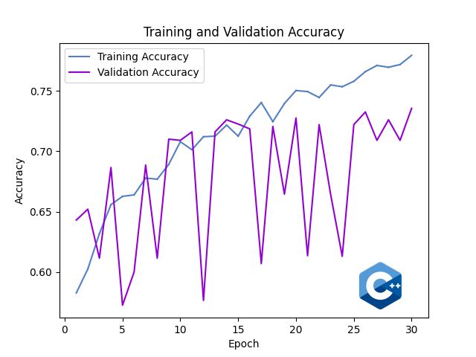
Figure 4 Cats Dogs CNN-CPP Accuracy
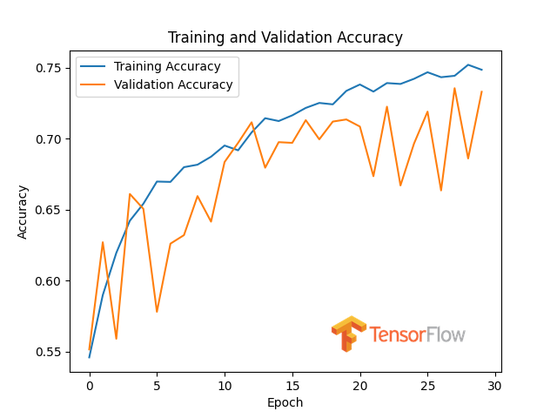
Figure 5 Cats Dogs TensorFlow Accuracy
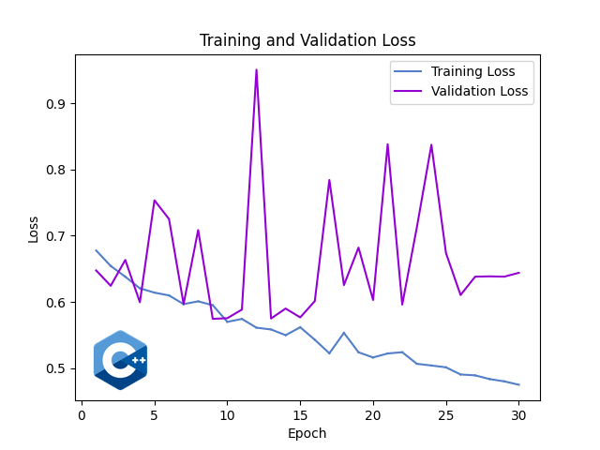
Figure 6 Cats Dogs CNN-CPP Loss
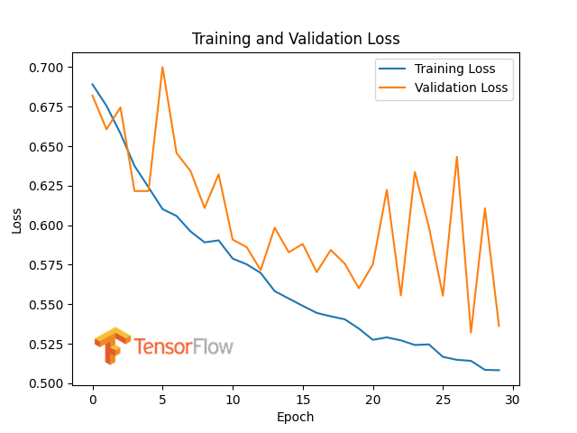
Figure 7 Cats Dogs TensorFlow Loss

  - CIFAR-10 Dataset
The model is trained and validated on the CIFAR-10 dataset [6], which contains 60,000 32x32 color images in 10 different classes:
- Training Data: 50,000 images of 10 classes.
- Validation Data: 10,000 images of 10 classes.
- Single Prediction Data: 10 images, one per class, downloaded from Google Images for single predictions.

Model Component | CNN-CPP Description | TensorFlow Description
Model Implementation | wmodels/cnn_cifar10_e10.hpp | tfmodels/cnn_cifar10_e10.py
Input Image Size | 32x32 pixels | 32x32 pixels
Convolutional Layer 1 | 32 filters, 3x3 kernel, ReLU | 32 filters, 3x3 kernel, ReLU
MaxPooling Layer 1 | 2x2 pool size | 2x2 pool size
Convolutional Layer 2 | 64 filters, 3x3 kernel, ReLU | 64 filters, 3x3 kernel, ReLU
MaxPooling Layer 2 | 2x2 pool size | 2x2 pool size
Convolutional Layer 3 | 64 filters, 3x3 kernel, ReLU | 64 filters, 3x3 kernel, ReLU
MaxPooling Layer 3 | 2x2 pool size | 2x2 pool size
Flatten Layer | Converts 4D Tensor to 4D Tensor(2D) | Converts 2D matrices to 1D vector
Fully Connected Layer 1 | 128 units, ReLU | 128 units, ReLU
Fully Connected Layer 2 | 10 units, Softmax activation | 10 units, Softmax activation
Loss Function | Categorical Cross-Entropy | Categorical Cross-Entropy
Optimizer | Adam with gradient clipping (clipvalue=1.0) | Adam with gradient clipping (clipvalue=1.0)
Learning Rate | 0.0005 (Step Decay) | 0.0005 (Step Decay)
Step Decay Params | Step Size: 1, Decay Factor: 0.7 | Step Size: 1, Decay Factor: 0.7
Batch Size | 80 | 80
Epochs | 10 | 10
Batch Mode | Shuffle Only | Flow From Directory
Augmentation | None | None
Table 3 Cifar-10 Model
CNN-CPP Prediction | TensorFlow Prediction
Prediction for 'cat.jpg' is 'cat' with confidence 42.5325%. ✅ | Prediction for 'cat.jpg' is 'cat' with confidence: 21.22%. ✅
Prediction for 'dog.jpg' is 'dog' with confidence 87.6412%. ✅ | Prediction for 'dog.jpg' is 'dog' with confidence: 66.92%. ✅
Prediction for 'frog.jpg' is 'frog' with confidence 91.7512%. ✅ | Prediction for 'frog.jpg' is 'frog' with confidence: 98.60%. ✅
Prediction for 'deer.jpg' is 'deer' with confidence 94.8323%. ✅ | Prediction for 'deer.jpg' is 'frog' with confidence: 76.39%. ❌
Prediction for 'bird.jpg' is 'bird' with confidence 94.2929%. ✅ | Prediction for 'bird.jpg' is 'bird' with confidence: 56.94%. ✅
Prediction for 'ship.jpg' is 'ship' with confidence 99.3474%. ✅ | Prediction for 'ship.jpg' is 'ship' with confidence: 96.62%. ✅
Prediction for 'horse.jpg' is 'horse' with confidence 77.5294%. ✅ | Prediction for 'horse.jpg' is 'horse' with confidence: 83.91%. ✅
Prediction for 'truck.jpg' is 'truck' with confidence 89.7804%. ✅ | Prediction for 'truck.jpg' is 'truck' with confidence: 90.47%. ✅
Prediction for 'airplane.jpg' is 'airplane' with confidence 99.8279%. ✅ | Prediction for 'airplane.jpg' is 'airplane' with confidence: 70.14%. ✅
Prediction for 'automobile.jpg' is 'automobile' with confidence 98.7025%. ✅ | Prediction for 'automobile.jpg' is 'automobile' with confidence: 95.32%. ✅
Table 4 Cifar-10 Inference Predictions

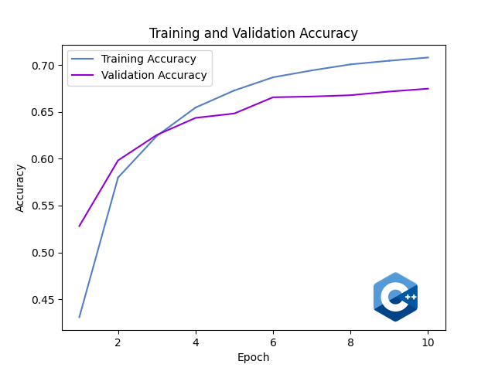
Figure 8 Cifar-10 CNN-CPP Accuracy
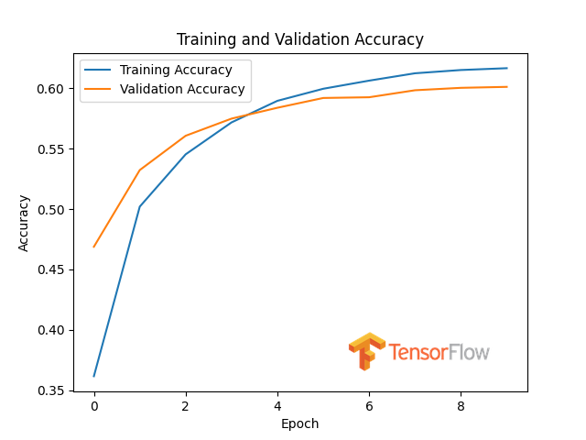
Figure 9 Cifar-10 TensorFlow Accuracy

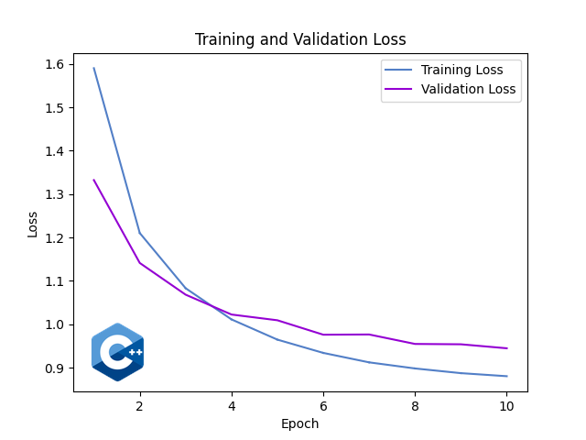
Figure 10 Cifar-10 CNN-CPP Loss
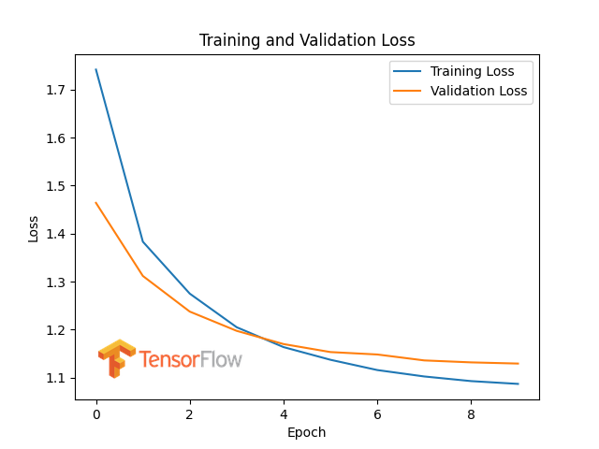
Figure 11 Cifar-10 TensorFlow Loss

Datasets
For seamless integration with this framework, datasets should follow a defined directory structure to enable automatic category detection and internal one-hot encoding, thus simplifying setup. The dataset directory should include three main folders: training_set, test_set, and single_predictions. Within the training_set and test_set folders, subfolders are required for each category, named according to the category they represent (e.g., car, boat, plane), containing images that correspond to those categories. Image filenames are irrelevant, as the directory structure alone defines categorization. The single_predictions folder is reserved for images intended for single prediction tasks. By adhering to this structure, the framework automatically recognizes categories and handles encoding, removing the need for any manual preprocessing.

Aditional Reading
This paper provides an overview of key functionalities in the CNN-CPP Framework but does not fully cover all available features. For a more detailed understanding, please refer to the README on GitHub [11], where additional topics like running the framework, creating models, and the mathematical concepts behind each layer are thoroughly explained. The README also covers ELRALES training metrics with different configurations and includes examples for various setups. Aditional results are contained there, for example model with batch normalization for MNIST dataset [12]. Apart from Readme, thehe framework’s documentation is generated using Doxygen, with all classes, methods, and major code structures annotated to follow Doxygen standards [13]. Doxygen extracts these comments to produce documentation in multiple formats, including HTML and LaTeX, providing a comprehensive reference for deeper exploration.

References
- "C++ Reference," cppreference.com, https://en.cppreference.com, Accessed Oct. 26, 2024.
- "C++ Insights," cppinsights.io, https://cppinsights.io, Accessed Oct. 26, 2024.
- "Eigen C++ Library Documentation," eigen.tuxfamily.org, https://eigen.tuxfamily.org/dox/, Accessed Oct. 26, 2024.
- "OpenCV C++ Documentation," opencv.org, https://docs.opencv.org, Accessed Oct. 26, 2024.
- A. Géron, Hands-On Machine Learning with Scikit-Learn, Keras, and TensorFlow, 2nd ed. Sebastopol, CA: O'Reilly Media, 2019.
- "CIFAR-10 Dataset," Canadian Institute for Advanced Research, https://www.cs.toronto.edu/~kriz/cifar.html, Accessed Oct. 26, 2024.
- Y. LeCun, L. Bottou, Y. Bengio, and P. Haffner, "Gradient-Based Learning Applied to Document Recognition," Proc. IEEE, vol. 86, no. 11, pp. 2278-2324, Nov. 1998.
- A. Krizhevsky, I. Sutskever, and G. Hinton, "ImageNet Classification with Deep Convolutional Neural Networks," Adv. in Neural Inf. Process. Syst., vol. 25, pp. 1097-1105, 2012.
- K. He, X. Zhang, S. Ren, and J. Sun, "Deep Residual Learning for Image Recognition," in Proc. IEEE Conf. Comput. Vision Pattern Recognit., 2016, pp. 770-778.
- I. Goodfellow, Y. Bengio, and A. Courville, Deep Learning, Cambridge, MA, USA: MIT Press, 2016.
- "CNN-CPP: A C++ Framework for Convolutional Neural Networks," GitHub repository, https://github.com/kolemare/CNN-CPP
- Y. LeCun, C. Cortes, and C. J. C. Burges, "MNIST handwritten digit database," http://yann.lecun.com/exdb/mnist
- "Doxygen Documentation," doxygen.nl, https://www.doxygen.nl

